Name:



**My Plastic Diary**

Over the next week keep a tally chart of how many single use plastic items you use.

|  |  |  |  |  |  |  |  |  |
| --- | --- | --- | --- | --- | --- | --- | --- | --- |
|  | Monday | Tuesday | Wednesday | Thursday | Friday | Saturday | Sunday | Total for the week |
| Plastic bottles |  |  |  |  |  |  |  |  |
| Plastic cups |  |  |  |  |  |  |  |  |
| Plastic bags |  |  |  |  |  |  |  |  |
| Plastic straws |  |  |  |  |  |  |  |  |
| Plastic food containers eg. yoghurt pots |  |  |  |  |  |  |  |  |

List here any other single use plastic items that you have used:



**My Plastic Diary**

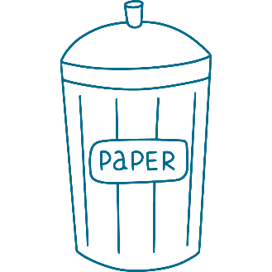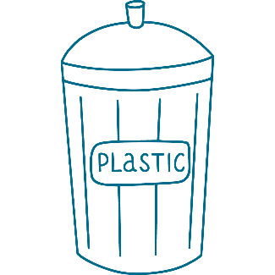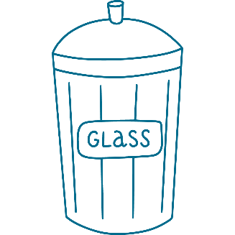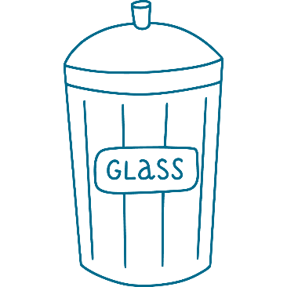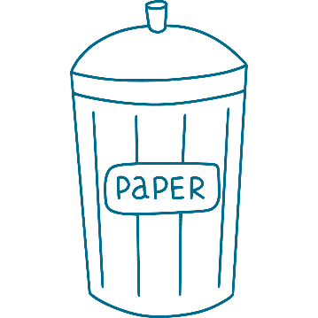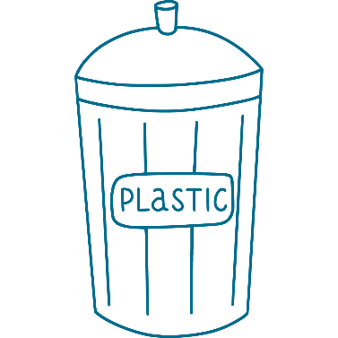What alternatives to single use plastics have you used or could you use in the future?

[www.ascentis.co.uk](http://www.ascentis.co.uk)